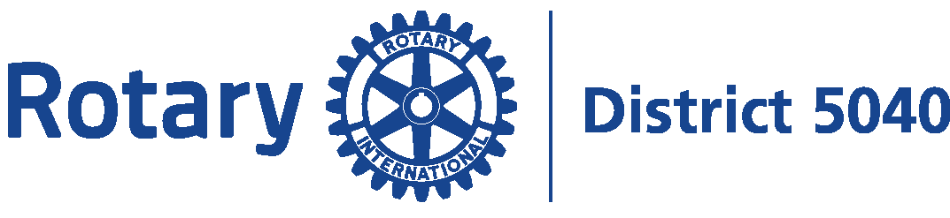
Diversity, Equity & Inclusion Committee

Member Recruitment Appeal through DEI and Values

A focus on membership size is important for any club. The more the members, the more the performance for the community and the world. In recruiting and retaining members, however, more and more the “Rotary experience” needs to focus on a marketing approach related to our values including Diversity Equity and Inclusion.

To look beyond the numbers and attract, engage, retain members based on Rotary’s values, including DEI, here some initial points to consider.

- It is expected by prospective members, sponsors and project partners that Rotary, along with other profit and non-profit organizations in our community, has a set of values, including the 4-Way Test and DEI.
- When making grant applications, a sponsor will consider Rotary’s provision of accessibility to club meetings, events and projects, its focus on peace and community and other factors included in DEI.
- Land acknowledgement is an important step at any Rotary meeting or event as part of DEI. This, and other aspects of DEI, can be included in communications to members and community groups and posted boldly on a club’s website.
- Inclusion of family is another aspect of DEI in Rotary.

The importance of DEI (excerpts from Zavvy)

As baby boomers leave the job market, more Gen Zs are entering, and millennials are becoming the core of the global workforce, representing 75% of the worldwide workforce by 2025. A global pandemic forced everyone to reconsider their life and priorities, especially about modes of work and work culture.

Part of these trends is changing attitudes to work and how personal time is spent: how employees select their employers and, as volunteers, members select causes and organizations to support. For young workers, company values and ethics can make a huge difference when selecting their employers and the same could be said about associations and societies where they might volunteer.

Millennials "want to work for organizations that foster innovative thinking, develop their skills, and make a positive contribution to society." -- highlights of a Deloitte Millenial Survey Report.

For Gen Z, company ethics are of utmost importance: "Not only must companies have strong ethics. They have to demonstrate they take action consistent with their ethics and values, and this action must be front and center of their brand for prospective Gen Z buyers and employees to see." -- Deloitte's Welcome to Generation Z Report.

Generation Alpha includes all those born since 2000. They are true digital natives. Their expectations for communication, collaboration and work/life balance will bring about significant shifts in workplace culture, technology adoption and recruitment strategies. They will likely demand greater flexibility and adaptability related to location, physical and mental health, remote work, gig opportunities and meaningful and enriching experiences over salary, job security and traditional career paths. Some food for Rotary now and looking down the road.

Diversity, Equity and Inclusion (DEI) are important topics for young generations – the future of Rotary and now quickly becoming its present.

99% of Gen Z workers report that workplace DEI is important, with 87% responding that it is very important.

DEI is a complex issue that touches on deeply rooted beliefs and behaviors.
Enacting a culture rooted in DEI principles might make a long term Rotary member uncomfortable addressing topics that are unfamiliar and ideas challenging their subconscious bias.

While there are no shortcuts to DEI, and it won't get fixed overnight, addressing these issues is part of creating a better environment and, in the long run, a better society! Never underestimate the ripple effect of seemingly small changes.

The Benefits of DEI

Members are more likely to support DEI efforts if they understand the many potential benefits. Below is a partial list of benefits of DEI for business success in a company identified by the members of Forbes Human Resources Council. They are points to consider in any service club such as Rotary.

- DEI is not a compliance mandate, it has become a performance imperative because it delivers better results.
- Inclusive organizations are more likely to hit financial goals.
- Diversity means you’re better representing what the world looks like and market served.
- Diverse teams bring diversity of thought to fuel new product or service development through creativity, innovation, than possible in a homogeneous culture with fewer perspectives.
- Members will feel a sense of belonging, so they feel the openness and safety to contribute their ideas from diverse mindsets to innovate, evolve and thrive.
- Innovation comes from diversity of thought and experience that unleashes innovation when members convey respect for different perspectives, listen with an open mind and foster inclusion and sharing.
- Inclusion creates a sense of psychological safety -- most important in a high-performing team -- as members bring their strengths, feel included and free up their minds and energy to focus on their performance.
- A diverse, inclusive environment retains members feel more connected through fellowship and service they will tend to be more committed to the organization and its overall direction.

What does Rotary do?

Rotary International is a global network of 1.4 million neighbors, friends, leaders, and problem-solvers who envision a world where people unite and take action to create lasting change.

We provide service to others, promote integrity, and advance world understanding, goodwill, and peace through our fellowship of business, professional, and community leaders.

Rotary members work together, in fellowship and friendship, to make a difference in these seven areas of local and global focus:
- Promote Peace to foster peace and understanding across borders;
- Fight Disease by supporting health initiatives and vaccination programs;
- Provide Clean Water, Sanitation, and Hygiene to improve access to clean water and sanitation facilities;
- Save Mothers and Children to ensure better health outcomes for both;
- Support Education, literacy and skill development;
- Grow Local Economies to enhance economic stability and prosperity in communities;
- Protect the Environment to achieve environmental sustainability.

We are People of Action, connecting passionate individuals with diverse perspectives to exchange ideas, forge lifelong friendships, and create positive change. Our multidisciplinary approach helps us see challenges uniquely, and we apply our expertise to address persistent problems. Together, we build stronger communities and a better world.

A service project typically begins because one member, or a small team of members from diverse backgrounds, want to make a difference in service above self. They speak up, attract other members, gain the financial support of their club and regional District, collaborate with community organizations and make it happen. Rotarians are People of Action. They work together in fellowship, in an environment of trust and integrity.

Members from diverse backgrounds, are included in planning and given equal opportunity to recommend direction of their clubs and service projects. Rotarians in this region have used the financial resources and volunteers of their clubs to achieve projects for communities here in BC and around the world.

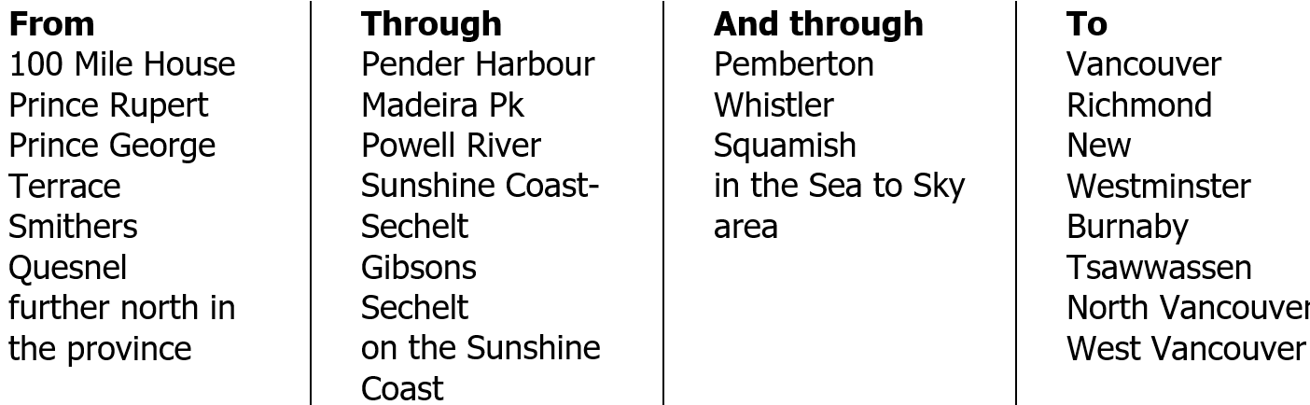

These are just examples of the kinds of Rotary community services projects here and afar started by people who want to give back in a trusted, ethical and productive environment.

- palliative care unit at a small hospital
- funding for a cystoscope at a hospital
- sun shade at a secondary school
- art gallery workshop series
- centre for disabled solar water heaters
- Special Olympics
- school lunch program refrigeration project
- dog park
- 100 survival garden kits for villages in South Africa
- breakfast program
- youth orchestra rotary bursary and scholarship
- backpacks of weekend food for youth in need
- center of hope in manila
- high school scholarships
- boots for kids
- handwashing stations in elementary schools in Philippines
- mothers learn and teach in neighbourhoods of Bangladesh
- Bali school for the deaf
- latrine block for boys' dormitory at primary school in Uganda
- kid's breakfast program
- food bank freezer
- paddling together program with First Nation community
- Bali clean water project
- coats for kids
- Rotary dog park
- youth hub
- special needs adults, families Christmas dinner
- StoryWalk of reading stations for kids along trail
- marine search and rescue
- days for girls
- 25+ libraries, learning centres in first nation villages in BC
- seniors Christmas lunch
- project amigo in Mexico
- community greenhouse
- seniors’ outdoor fitness project
- tree planting
- ebike charging and bench for town plaza
- community garden
- prison mattresses
- bikes for schoolgirls to get to school in African villages
- boulder climbing park
- community school society
- water filters for remoted villages of Laos

In providing service, the way Rotary does it is as important is what it does

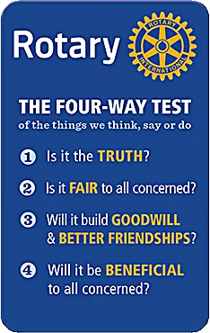
Since 1932 Rotarians have brought trust and integrity to everything they do and say with each other and with their community partners by living at home and on the job by the “4-Way Test”.

Living by a culture of Diversity, Equity and Inclusion, where people of all ages, genders, occupations, ethnic backgrounds can speak up, be heard and belong, members of Rotary clubs in this region and worldwide have demonstrated that they are People of Action in service above self.

This “Rotary experience” is what members seek and new members want as they achieve what their community need through fellowship and friendship. This has been the appeal of Rotary for millions of people worldwide for the past almost 120 years.

People want different things from DEI (diversity, equity, and inclusion) depending on their backgrounds, experiences, and perspectives. Some common themes that emerge as search results, related to employees of organizations, transferable to members, are:
- people want to feel welcome and supported in the workplace, regardless of their identity or group membership Read more;
- people want to have fair treatment and equal opportunities for advancement and recognition, without being discriminated against or marginalized Read more;
- people want to learn from, and collaborate with, others who have different views, skills, and experiences, and to contribute to the innovation and success of their organizations. Read more.

DEI is not a one-time initiative, but an ongoing process of creating a positive culture that values and respects diversity, equity, and inclusion. DEI requires commitment, effort, and understanding from everyone involved.

Rotary members want and expect from their Rotary experience: respect, ethical leadership, inclusion, and the opportunity to work together to create more just open, and welcoming communities for all people.

These ideals reflect Rotary’s core values and vision of a world where people unite and take action to create lasting change.

Rotary International believes that cultivating a diverse, equitable, and inclusive culture is essential to realizing this vision. Diversity, equity, and inclusion (DEI) are integral to Rotary’s vision of a world where people unite and take action to create lasting change

We value diversity and celebrate the contributions of people of all backgrounds, across age, ethnicity, race, color, disability, learning style, religion, faith, socioeconomic status, culture, marital status, languages spoken, sex, sexual orientation, and gender identity as well as differences in ideas, thoughts, values, and beliefs.

Recognizing that individuals from certain groups have historically experienced barriers to membership, participation, and leadership, we commit to advancing equity in all aspects of Rotary, including in our community partnerships, so that each person has the necessary access to resources, opportunities, networks, and support to thrive.

We believe that all people hold visible and invisible qualities that inherently make them unique, and we strive to create an inclusive culture where each person knows they are valued and belong.

We believe that exemplifying and embracing diversity, equity, and inclusion (DEI) should be a part of everything we do at Rotary.

Current members can progress through the stages of awareness through to action to remain committed to Rotary, remain active and engaged and appeal to prospective members. Prospective members can transition through these stages as well to reach the final stage and act to join.

DIVERSITY EQUITY INCLUSION AND THE FOUR-WAY TEST

Rotary’s values shared among 1.4 members worldwide.

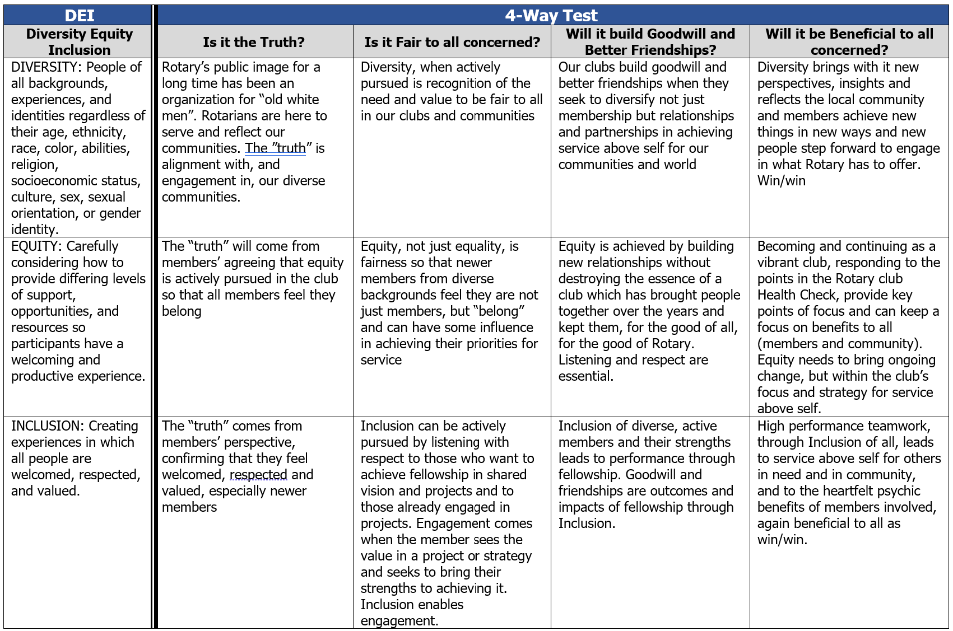

DEI MESSAGES TO CONSIDER IN PLANNIING COMMUNICATION WITH GROUPS
 |  |  |  | ACTION
 |  |  | COMMITMENT
 |  | UNDERSTANDING
 | AWARENESS
MEMBERS | Long ago women were welcomed into Rotary  DEI is a continuation of that movement  DEI is not a project, it is an evolving way of life for Rotary clubs  It reflects the way our communities and world are evolving  It is not intended to displace members and impose change  It is a culture to embrace over time to broaden the capacity of a club to achieve service of many kinds, in many ways | DEI is not intended to replace what we value in Rotary. It is intended to expand or enhance what we already do for our community: how we live our club culture and how we do what we do.  The image of Rotary is outdated and does not align with values of younger people. DEI appeals to younger people. It is essential for them to even consider membership. DEI brings innovation, new ideas and relationships. It makes Rotary more relevant in today’s world and is a key to our sustainability. | There are many ways for a club to adopt a culture of DEI. The District DEI Committee is available to advise. It aligns with all four of Rotary’s Action Plan key results areas: Expand Our Reach; Increase Our Impact; Increase Our Ability to Adapt; Enhance Participant Engagement. To be an upstander, not a bystander, we need to celebrate cultural events with the community, in the club and in the community. We need to think and act differently and do more to bring in more women, younger people, people from different cultures and occupations so they can achieve community service through Rotary. | What is the profile of the community? Does the club reflect that profile in terms of occupation, gender, ethnicity? What are the issues or needs in the community? How can representatives of those needs achieve some of their goals through membership in Rotary? Can the cost of being a member be changed? Can the time and place to meet be changed? Can the club focus on a certain cause? Can it form a Satellite Club for those who could meet as members at different times and in different ways?
PROSPECTIVE MEMBERS | Rotary is the world’s oldest service club, driven by values in service above self since its founding in 1905. 1.4 million members around the world live values that call for truth, trust, integrity as they give back to their communities. Rotary can be found many times when there is need in places where we live, work and play. People who have a cause which needs support - be it local or global - can help that cause through Rotary. DEI is expanding our ability to do that in an ever changing community and world. | Rotary clubs in District 5040 have made a wide range of contributions to the communities here and far away. [List some examples.] Do you have a cause which you want to support? DEI is bringing change to Rotary as the world changes. To achieve these and new kinds of service projects of the future we need the diverse ideas, experience, perspectives that lead to innovation, team-building, connections of women and men of all ages, cultural backgrounds, abilities. We need them to bring their causes so Rotary can achieve their goals with volunteers and funds. | What are causes you care about? Do you know of others who share your cause? You and those colleagues or friends can visit our club. Talk to our members about your cause. Work out a way Rotary can achieve your goals. Make Rotary yours. We all learn from each other and work together in fellowship and friendship in an environment of respect, trust, integrity and fun. With you, we become People of Action. | Now that you have joined the club, what are key interests or causes? Would you like to engage in current club projects? If so, we can connect you to those involved in the projects. Do you want to start a project which addresses a need you have identified, in the community here or in the province, country or world? How would you like to proceed? What relationships do you need to build?  Volunteers – in the club and in the community – can join you. Fundraising events and Foundation grants can provide financial resources.
COMMUNITY | Rotary is the oldest service club in the world. It has grown to 1.4 million members worldwide over almost 120 years because it is driven by values around “service above self”. People join because they want to give back to their community and the world.  Our priorities, at home and abroad, are fighting disease, providing access to clean water and sanitation facilities, saving mothers and children to ensure better health, supporting education and literacy, growing local economies to enhance economic stability and prosperity in communities, and protecting the environment for a sustainable future.  We welcome members who see a need in those areas near or far. We welcome supporters and partnerships with organizations who share those priorities in making our community and our world a better place to live a fulfilling life. | There is a high level of integrity and trust in the Rotary environment - in service above self, where there is a need. In that environment members become engaged in the fellowship of service which builds friendship.  In the things Rotarians think, say or do, we continually ask ourselves whether it's the truth, fair to all concerned, building goodwill and better friendships and will be beneficial to all concerned. It's our 4-way test.  All the many kinds of service projects [refer to or list examples of projects] arise and develop around this trusted, safe environment and these values.  We attract members not only by what we do, and what we can do, in achieving their goals, but by how we do that.  Diversity, Equity and Inclusion is important because it makes us innovative, open to new ideas of what can be achieved and how, and respects and draws on the strengths each member can bring to our causes and theirs. | Rotarians are People of Action. We identify a need in a community here at home or around the world and act in some small or large way to make a difference. We seek to connect, inspire, transform, fight hunger, empower and fight polio. In 1986, for example, the world had been suffering from 350,000 new cases throughout 120 countries every year of the lifetime debilitating sometimes fatal disease of polio. It started a global campaign in the Philippines which has grown over the years to include health agencies, foundations and governments to reduce that final level of just tens of cases in two countries. That's the global impact of Rotary. In our community [description of local project] is a smaller scale, but important, version of that global campaign because there was a need.

ZAVVY, https://www.zavvy.io/blog/promote-diversity-equity-and-inclusion-in-the-workplace
Some examples of the value of DEI taken from Forbes

