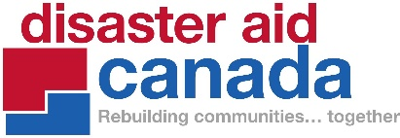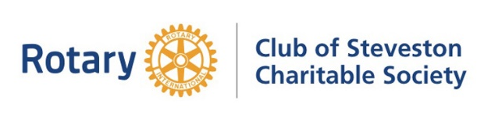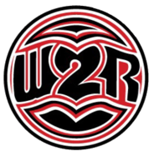
DAC & RCSRCS 2024-2025 Fire Trailer Project
Announcement of the Project – August 23rd 2024
The Story Behind the Story of the 2024-2025 Fire Trailer Project
Since 2017, the increasing threat from wildfires in British Columbia and across the Pacific Northwest have highlighted the need for locally based, designed, and manufactured firefighting equipment to serve and protect rural and remote communities.
Disaster Aid Canada (DAC) & Rotary Club of Steveston Richmond Charitable Society (RCSRCS) 2024-2025 Fire Trailer Project is an example of participation, partnership, and power sharing through ongoing relationships and trust building, to social action based on working with communities so their voice, their needs are centred. The 2024-2025 Fire Trailer Project has secured over $350 thousand dollars in funding via DAC that will enable them to work in partnership with seven First Nation communities and one unincorporated regional district area in rural and remote British Columbia to supply “Fire Trailers” to begin to meet this need.
This partnership has been in place since the 2021 devastating wildfire that wiped out Lytton, British Columbia and impacted all the surrounding First Nation communities. RCSRCS provided relief support to the Lytton area in the interior of British Columbia by raising over $175,000 that was used primarily to work with Siska First Nation members to support a food bank in a regional relief centre located in the community hall. Together we formed the joint Fire and Flood Relief Team. As part of this joint relief effort, DAC also raised $148,000 in funding that provided, among other things, a full set of Self-Contained Breathing Apparatus for Lytton Fire Rescue, gas and food vouchers to support evacuees, and support when the floods hit after the fires to provide helicoptered in food and supplies to the Lytton, British Columbia and the surrounding First Nations communities. Based on the future needs identified by the Siska First Nation, our joint attention has now expanded to include wildfire preparedness, prevention and mitigation. DAC, RCSRCS and Siska First Nation have worked collaboratively with a local company to design and build a prototype “Fire Trailer” to address this need (see drawing below).
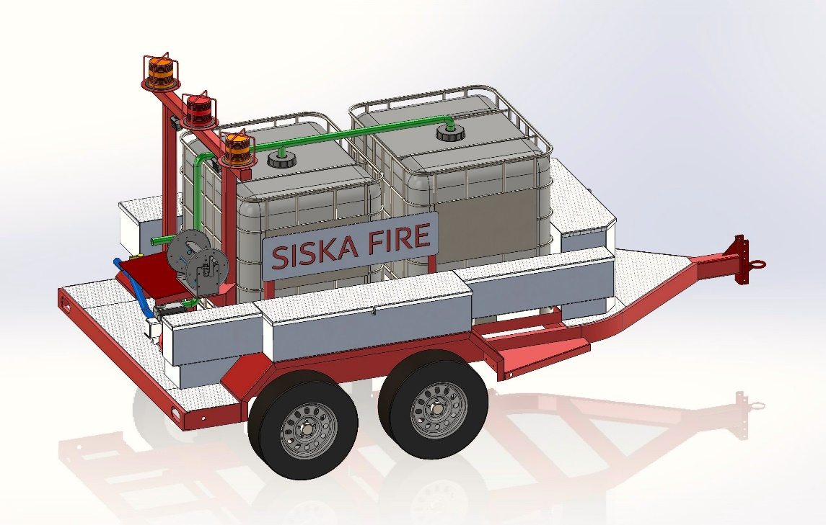
Why a “Fire Trailer”? In the summer of 2023, when the Fraser Canyon was on fire, Siska member of Fire and Flood Relief Team Jason Phillips sent a message to District Governor 2008-2009 & RCSRCS Vice-President Bob Blacker.
“Jason asked if I had any idea where he could get some firefighting equipment. Specifically, he was looking for equipment that was easy to get around and into hard to access areas and could deal with spot fires. He also asked if I knew anything about getting a tote and fire pump that could be hauled around by a pickup truck. I immediately knew what he was after, and I set about to see what I could find.”
Bob quickly found out that what Jason was asking for may not do the job. As it happens, Bob’s brother Warwick in his native Australia, was a Senior Deputy Captain of a Bush Fire Brigade in a small, isolated community two hours north of Sydney.
“He mentioned to me that maybe a trailer with totes and a water pump would be more suitable. He said that his Fire Brigade had used them in the great bush fire at the end of 2019 and early 2020. What they did was to put the trailers in strategic locations surrounding the community so if a community members sees a fire starting they could go to the trailer and possibly be able to put the fire; thus saving time before the Fire Truck would arrive. The bottom line was that they worked really well.”
The Fire and Flood Relief Team knew this was a great idea so and set about to find something in Canada – no luck!
Fire and Flood Relief Team members Bob and Shirley-Pat (District Governor 2023-2024) both know from their work with First Nation communities via the Write to Read BC Project (writetoreadbc.com) that many communities do not have any fire protection and could benefit from a “Fire Trailer”. As Bob notes,
“When Jason asked for help, I knew that if we got a “Fire Trailer” then once we had a prototype, we could then supply other First Nation and rural or remote communities for their protection, not only for wildfires but also protection of personal property. As a result, I started to look for manufacturers that could build a trailer. I had a photograph of the Aussie fire trailer, but I needed help with the design. Jason and I started the process of designing one. After searching right across Canada I was able to find a manufacturer who would agree to build a trailer and luckily his plant was in Steveston-Richmond, where I live. Through some going back and forth we were able to come up with the design. What makes the Rotary “Fire Trailer” design unique is that it can fit inside a 20 foot sea can. This will keep the trailer secure plus well protected from the elements.”
The first Rotary “Fire Trailer” prototype was designed in collaboration locally and is currently under construction. The prototype is being jointly funded by DAC & RCSRCS. This prototype has been developed with and will be donated to the Siska First Nations. Siska will then be responsible for training their operators, operation, maintenance, licensing and insurance of the apparatus. The Siska Prototype Team will work with the 2024-2025 Fire Trailer Project and this collaboration will enable us to leverage these learnings and expertise for the 8 identified communities.
The 2024-2025 Fire Trailer Project is being funded in its entirety solely through DAC and the RCSRCS partnership enables this project to also leverage the 15+ years of both DAC’s disaster aid work and the work of the RCSRCS through the Write to Read BC Project (W2R). The key protocol of working with means the key group we must work with Skuppah First Nation, Kanaka Bar First Nation, Lytton First Nation, Botanie – unincorporated regional district area, Tsideldel First Nation, Yunesit’in First Nation, Tles’qox First Nation, and Xeni Gwet’in First Nation.
Their needs will be different, and we are committed to working with them to incorporate their input into the plans for these individual units within the 2024-2025 Fire Trailer Project. Responsiveness is key and although the trailer itself will not be customized the delivery, turn over process and training will be. This will require both zoom and in person meetings, working together to prepare the site for delivery of the storage and firefighting unit, process of passing on possession, and hands on training with the Siska Prototype Team. The 2024-2025 Fire Trailer Project therefore will utilize this prototype Rotary “Fire Trailer” design to complete the construction, outfitting, and supply of the additional 8 Fire Trailers will meet the needs of these rural and remote places. For the 8 units in this proposed 2024-2025 Fire Trailer Project, each community will be responsible to prepare the site for the storage container and for ongoing training of their operators, cost to heat the storage unit, repairs and maintenance, licensing and insurance. The goal is to provide a simple, rugged, effective firefighting apparatus at an affordable cost. It is designed for operation by community members with basic training, and a suitable vehicle to tow it. This micro-firefighting apparatus can respond to small, localized fires near the community - before they grow into large-scale wildfires. It can go to remote spaces and places fire trucks cannot. It can also be used to fight fires within the community that threaten residents, along with their housing, community buildings and infrastructure.
The Fire Trailer includes:
- a heavy-duty frame and running gear to handle rough roads, and even off-road conditions
- 2.000 l of water storage, with a high-capacity pump
- fire hoses and piping, including an alternate intake hose for filling from creeks, ponds, etc.
- storage for hoses and fire-fighting equipment
- a small generator and a lighting system
- Anchor Points that will enable the trailer to be lifted by Helicopter when required for hard to access locations
Once the 2024-2025 Fire Trailer Project is completed there is the potential for the findings to apply to many more rural and remote or small communities both in BC and across the country. There is a clear need therefore to provide a local quick firefighting response capability to protect these rural and remote places and the same holds true for many other First Nations in the province and across the country. These fire trailer units could also be utilized by regional districts, rural and remote communities, ranches, organizations, and associations both provincially and nationally.
Disaster Aid Canada (DAC)
Disaster Aid Canada was founded and is governed by Rotarians, driven by a deep commitment to compassion and solidarity. DAC provides essential equipment, materials, and financial support to those impacted by disasters and crises. From responding to the devastating effects of the Ukraine invasion to aiding communities affected by wildfires and floods in British Columbia, DAC stands as a steadfast pillar of support during times of adversity. Leveraging the Rotary International network of 1.2 million members in 46,000 clubs worldwide, and the Disaster Aid International network of 11 partnering countries, DAC collaborates directly with local leaders in disaster-affected communities across Canada and globally. This approach ensures that relief efforts are tailored to the specific needs of each community, using local knowledge to guide effective and timely assistance. For over two decades, DAC has remained committed to serving communities in need, providing vital humanitarian relief, and acting as a beacon of hope in times of crisis.
Be sure to check out DAC’s 20th Anniversary ‘20/20 Challenge’ and the incredible Bruinewoud family’s pledge to match donations that include the number "20." Visit DAC’s website for more information. (https://www.disasteraid.ca)
Rotary Club of Steveston Richmond’s Charitable Society (RCSRCS) and the Write to Read BC project (W2R)
Rotary Club of Steveston Richmond’s Charitable Society supports the work of the Rotary Club of Steveston Richmond (https://stevestonrotary.ca), primarily focusing on basic education and literacy, relieving poverty by providing food and other necessities of life, supporting families in need. RCSRCS is also the home of Rotary and Government House’s joint Write to Read BC project (www.writetoreadbc.com) which is an equal partnership between participating Indigenous communities, Rotarians, and volunteers with a range of diverse skills represented on the Write to Read Team. The collaboration creates relationships between Indigenous and non-Indigenous individuals, organizations, and communities through shared power and builds on a foundation of honesty, trust and equitable respect in the larger pursuit of social justice. The protocol of working with First Nations has been key to completing over 30 Write to Read BC libraries and learning centers.
Fire and Flood Relief Team (Siska members: Regina, Angela, Tammy, Alice Jason, Dennis, and Lorette, and Rotarians: Bob, Bill, Shirley-Pat, Gary, Linda and Frank)

