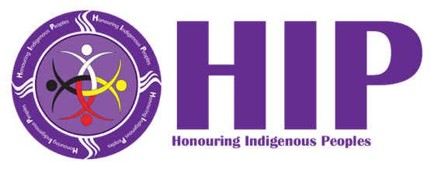
Youth-to-Youth Truth and Reconciliation Experience
Zajac Ranch, Mission, B.C.
March 24-30, 2024

Y2Y is a transformative program that immerses Indigenous and non-Indigenous youth between the ages of 15 and 17 in Indigenous culture while fostering connections with a diverse group of young people from across Canada. They engage in meaningful cultural exchanges, learn about Indigenous traditions, and deepen their understanding of Indigenous history and heritage.

Through activities, workshops, and interactive sessions, youth are encouraged to embrace diversity, build relationships, and develop a greater appreciation for Indigenous perspectives and contributions. This experience serves as a catalyst for personal growth, intercultural learning, and fostering lasting connections.

Who is eligible?
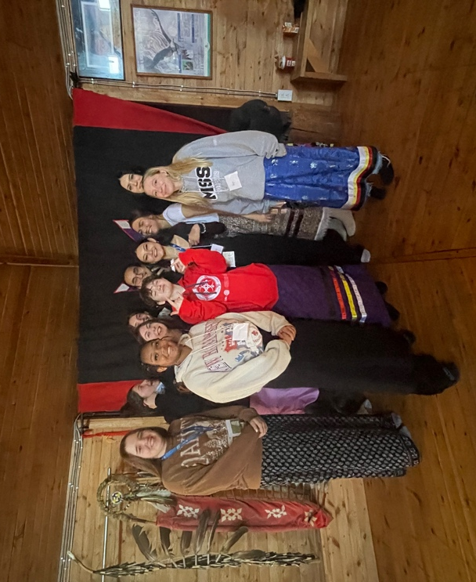
Indigenous, self-identified Indigenous and Non-Indigenous youth (male, female, LGBTQ2S & disabled) interested in being an agent for change and currently enrolled in Grades 9 to 11. Applicants for the 2024 HIP Reconciliation experience must be between the ages of 15 and 17 as of March 1, 2024, meaning they are born on or between March 2, 2007, and March 1, 2009.

How much does it cost?
This event is free and includes travel to and from the event, accommodations, food and museum admission. Only 50 youth will be chosen from across Canada.
How do students apply?
Students apply online. Applications are reviewed by the HIP National Y2Y Committee. Participants will be selected and notified before Jan. 31, 2024.

What is Honouring Indigenous Peoples (HIP)?
An organization started almost ten years ago by Rotarians nationwide that brings together Indigenous and non-Indigenous Canadians with an emphasis on relationship building, to support the next generation of leaders and changing knowledge, attitudes and behaviours. Our board is comprised of 50% Indigenous and 50% non-Indigenous, and is gender balanced and geographically dispersed from coast-to-coast.

What can students expect?
This video from the 2023 HIP Reconciliation experience provides an excellent overview of the kinds of activities youth will participate in and what they will personally gain from this experience.

Where can I find more information?
Please visit our website or contact us via email at info@hipally.com or your local Rotary district coordinator.

