
Diversity Equity Inclusion

Transition to DEI Proposal

Proposed

That the Rotary Club of [name] ensures that it continues as a relevant and sustainable organization in service above self to our community and world by becoming more diverse, inclusive and equitable in a way and at a pace most appropriate to the club and its members.

Purpose
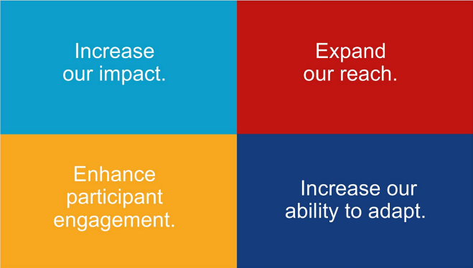
In a rapidly changing environment, organisations are in an endless state of change. Constant change means that organisations and their employees and members have to be very flexible when it comes to handling the status quo. There are four key result areas in Rotary’s Action Plan. Diversity, Equity and Inclusion relates to all four key result areas.

While Rotary overall is a model of DEI, many of our 35,000 clubs are not, including some in District 5040. Rotary International has invested considerable effort into adopting a DEI development strategy as a way forward to a culture which can adapt to ongoing change. DEI as culture of our clubs is the change needed. Change management means achieving needed change through a process of transition.

In 2021 Rotary District 5040 formed a DEI Committee to work with our 48 clubs on ways they can choose to reflect the communities they serve, develop and become more relevant by engaging with them, and become more sustainable through their own strategies related to DEI.

To establish a starting point in consulting with our clubs, the District DEI Committee conducted a survey with all District members to determine levels of awareness, understanding and commitment to DEI. One of the 15 recommendations which emerged from the survey was: "Develop an overall transition plan to achieve the change towards DEI in our clubs and District." This proposal addresses that recommendation.

The new DEI strategy is the change needed in Rotary: that is, members' engaging in DEI and operating their clubs accordingly, in a less exclusive, more open style. Below are the basic steps in a communication process. Ladner Rotary can determine where its members are in this process regarding DEI.

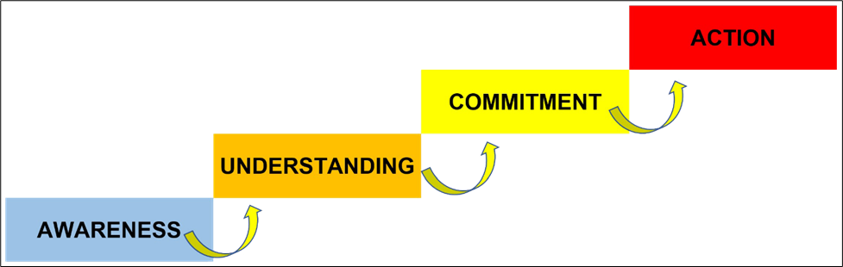

People are not afraid of change. They are often concerned about new ways of doing their activities or business because they are dedicated to, and perhaps enjoy, the way they have always done things, as you ask them to leave their comfort zones.

[Name of club] can take advantage of the consulting service which the District 5040 DEI Committee provides to make the transition to DEI, appropriate to the Ladner community and Delta city, as a way of life through as simple and effective process as possible over months and years as required.

A basic timeline for this transition to a culture of DEI might include these steps.
- Appoint a club DEI leader and form a team to lead the DEI transition process.
- Develop a process for the club to assess its DEI status.
- Recommend options to club members on developing an action plan of changes and communication to achieve DEI to meet their needs.
- Explore how the DEI and other District committees and leadership groups can support the transition of the club to a culture of DEI.
- Update club members quarterly or periodically on advances in implementing the Rotary DEI strategy.

Budget: no cost

