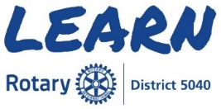
New Rotarians & Continuing Education
The Learning Center within My Rotary contains courses that enable
Rotarians to learn at anytime from anywhere.

You will need a My Rotary account to access the Learning Center
Rotary.org/My Rotary/Learning & Reference/Learning Center/
Rotary Courses - English
New Rotarians:
Rotary Basics
Rotary Foundation Basics

Further Rotary Education:
Membership - Learning Plan
Practicing Flexibility and Innovation
Essentials of Understanding Conflict
Mentoring Basics
Club Rotary Foundation Committee Basics - Learning Plan
Grant Management Seminar - Learning Plan
Protecting Youth Program Participants
Club Public Image Committee Basics - Learning Plan
How to start a Community based Rotaract Club
All About Rotary Peace Fellowships
Leading Change
Club Administration Committee Basics - Learning Plan

Please note the above are only a few of the courses available and new courses
are being added regularly. We encourage you to explore the Learning Center
and broaden your knowledge of Rotary to enhance & increase our impact.

